Robotic Arm Manipulator: An In-Depth Look

By Steve Prokovas Chief Engineer of MSC Group

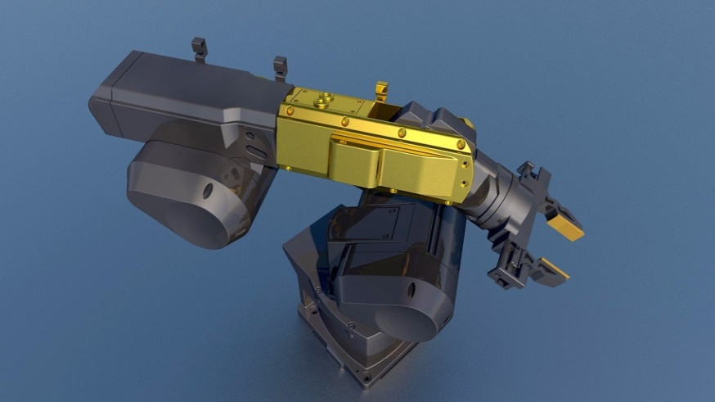A robotic arm manipulator is a type of robot that is specifically designed to perform a wide range of tasks that involve the manipulation of objects. The robot is typically composed of a number of different mechanical, electronic, and software components that work together to control the movement of the arm and the end effector. In this essay, we will delve deeper into the kinematics of a robotic arm manipulator, as well as how artificial intelligence (AI) can be used to improve its performance.

1.1 Mechanical Engineering Perspective

A robotic arm manipulator is a complex machine that is specifically designed to perform a wide range of tasks that involve the manipulation of objects. The mechanical engineering perspective of a robotic arm manipulator focuses on the design and construction of the mechanical components that make up the robot, and how they work together to achieve precise movement and control.

The mechanical components of a robotic arm manipulator include joints and links. The joints are the points where the different sections of the arm are connected and allow for movement. The joints are typically controlled by motors, which rotate the joints to move the arm. The links are the different sections of the arm that connect the joints and are typically made of lightweight materials such as aluminum or carbon fiber to reduce the weight of the arm and increase its mobility.

One of the key challenges in designing a robotic arm manipulator from a mechanical engineering perspective is to ensure that the joints and links are able to move with a high degree of precision and accuracy. This requires a careful consideration of the materials and manufacturing processes used to create the joints and links, as well as the types of motors and actuators used to control the movement of the arm.

Another important aspect of mechanical engineering for robotic arm manipulator is the kinematics. Kinematics is the study of the movement and motion of the robot, and how the different joints and links work together to achieve this movement. Understanding the kinematics of a robotic arm manipulator is essential for designing and constructing the robot in a way that allows it to move and manipulate objects with a high degree of precision. In addition to the kinematics, the mechanical engineering perspective also involves the study of dynamics, which deals with the forces that act on the robot and how they affect its motion. By understanding the dynamics of a robotic arm manipulator, engineers can design the robot to have the appropriate strength and stability to perform a wide range of tasks.

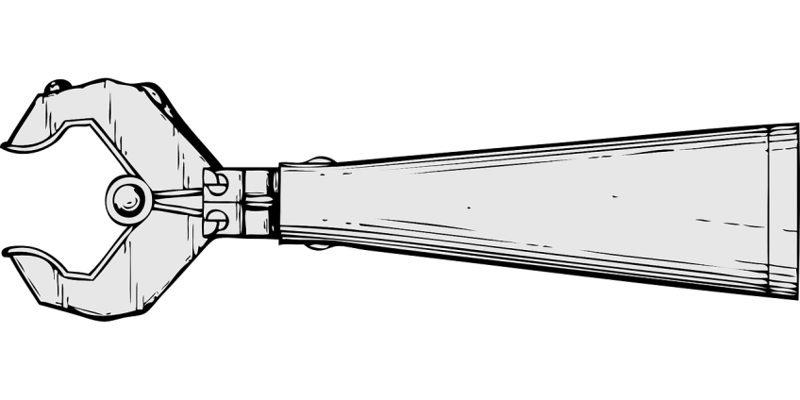The mechanical engineering perspective of a robotic arm manipulator is focused on the design and construction of the mechanical components that make up the robot, and how they work together to achieve precise movement and control. The joints and links of the arm are critical for its movement, and the kinematics and dynamics are essential to understand the movement and forces acting on the robot. With the combination of the mechanical engineering, a robotic arm manipulator can be designed to perform a wide range of tasks with high precision and accuracy.

1.2 Electrical Engineering Perspective

The electrical engineering perspective of a robotic arm manipulator focuses on the installation and integration of electrical components, such as sensors and actuators, to enable the robot to perceive and interact with its environment. These components are connected to the arm structure and the power supply, and communicate with the control system to control the movement of the arm.

The electronic components of a robotic arm manipulator include sensors, actuators, and control systems. Sensors, such as encoders, force sensors, and cameras, are used to detect the position and movement of the arm, as well as to perceive the environment, while actuators, such as motors and servos, are used to control the movement of the arm. The control system, which is typically composed of a microcontroller, a single-board computer, or a PC, receives input from the sensors, process it and sends commands to the actuators to control the movement of the arm and the end effector.

One of the key challenges in designing a robotic arm manipulator from an electrical engineering perspective is to ensure that the sensors and actuators are able to work together to achieve a high degree of precision and accuracy. This requires a careful consideration of the types of sensors and actuators used, as well as the design of the control system. For example, using high-resolution encoders and high-precision servo motors can greatly improve the precision and accuracy of the robot's movement. Also, using advanced sensors such as LiDAR or RGB-D cameras can greatly improve the perception capabilities of the robot. The encoders are devices that measure the rotation of the joints, providing position and velocity feedback to the control system, while the force sensors are devices that measure the forces and torques applied on the robot, providing valuable information for the control system to prevent overloading or collision.

Another important aspect of electrical engineering for robotic arm manipulator is the power supply and power management. The robotic arm needs a reliable and robust power supply to operate. Engineers need to consider the power requirements of the robot, including the motors, the control system, and the sensors, and design the power supply and power management accordingly. This can include the use of batteries, power converters, and other components to ensure that the robot has a stable and reliable source of power. The power management system is responsible for managing the power usage of the robot, ensuring that the robot does not exceed the power budget and that the power distribution is adequate.

The electrical engineering perspective of a robotic arm manipulator is focused on the design and construction of the electronic components that make up the robot, and how they work together to control the movement of the arm and the end effector. The sensors and actuators are critical for the robot's movement and perception, and the control system is essential to coordinate the movement and the tasks of the robot. Power supply, power management, and Artificial Intelligence are also important aspects to consider. With the incorporation of these different aspects, the robot's performance can be greatly improved

1.3 Software Engineering Perspective

The software engineering perspective of a robotic arm manipulator focuses on the design and implementation of the software components that make up the robot, and how they work together to control the movement of the arm and the end effector.

The software components of a robotic arm manipulator include the control software and the programming software. The control software is responsible for receiving input from the sensors, processing the input, and sending commands to the actuators to control the movement of the arm and the end effector. The programming software is used to program the arm to perform a specific task. Both of these software components are typically written in programming languages such as C++, C#, or Python, and are designed to be easy to use and understand.

One of the key challenges in designing a robotic arm manipulator from a software engineering perspective is to ensure that the control software and programming software are able to work together to achieve a high degree of precision and accuracy. This requires a careful consideration of the design of the software, as well as the use of software development best practices such as software testing. The control software should be designed in a modular way, to facilitate the integration and testing of different modules.

An example of a simple control software in C++ for a robotic arm manipulator could be as follows:

# include <iostream>

# include <stdio.h>

# include <stdlib.h>

# include <unistd.h>

int

main()

{

while (true) {

// Read sensor data

double sensor_data = readSensorData();

// Process sensor data

double actuator_commands = processSensorData(sensor_data);

// Send commands to actuators

sendActuatorCommands(actuator_commands);

// Sleep for a short period of time

usleep(1000);

}

return 0;

}

This example demonstrates a simple control loop that reads sensor data, processes the sensor data, and sends commands to the actuators. The loop runs continuously and sleeps for a short period of time between iterations to prevent overloading the system.

The software engineering perspective of a robotic arm manipulator is focused on the design and implementation of the software components that make up the robot, and how they work together to control the movement of the arm and the end effector.

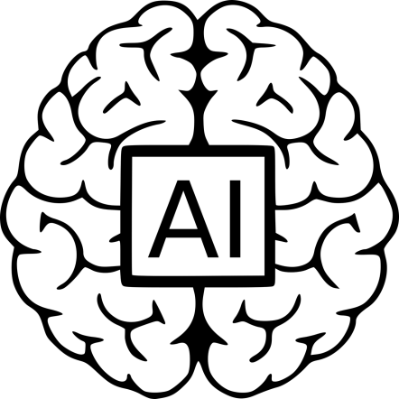1.4 Artificial Intelligence

Artificial Intelligence (AI) is a rapidly growing field that has the potential to revolutionize the way robots are designed, built, and operated. The integration of AI into arm robot manipulator systems can greatly improve the robot's ability to perform tasks and adapt to new situations.

One of the key applications of AI in arm robot manipulator systems is in the area of object recognition. AI algorithms such as computer vision can be used to improve the robot's ability to recognize and identify objects in its environment. For example, a robot equipped with a camera and machine learning algorithms can be trained to recognize different types of objects, such as tools or parts, and then use that information to make decisions about how to interact with those objects.

Another important application of AI in arm robot manipulator systems is in the area of task planning and execution. AI algorithms such as machine learning can be used to improve the robot's ability to plan and execute tasks with greater efficiency and accuracy. For example, a robot equipped with machine learning algorithms can be trained to optimize its movement patterns to minimize energy consumption or to avoid collisions.

Another important aspect of AI in arm robot manipulator systems is in the area of real-time control. AI algorithms such as deep learning and reinforcement learning can be used to improve the robot's ability to make decisions and respond to changes in its environment in real-time. For example, a robot equipped with deep learning algorithms can be trained to predict and correct errors in its movement, or to respond to unexpected obstacles in its environment.

In order to achieve the benefits of AI for arm robot manipulator, engineers need to consider a number of factors when designing and implementing AI systems. One of the most important factors is data availability. AI algorithms require large amounts of data to learn and improve, so engineers need to ensure that the robot is equipped with sensors that can provide the necessary data. Another important factor is the computational power of the robot. AI algorithms require significant computational resources to function, so engineers need to ensure that the robot is equipped with powerful processors and sufficient memory.

Artificial Intelligence (AI) is a rapidly growing field that has the potential to revolutionize the way robots are designed, built, and operated. By integrating AI into arm robot manipulator systems, engineers can greatly improve the robot's ability to perform

1.5 Assembly

The assembly of a robot arm manipulator is a multi-disciplinary process that involves the integration of mechanical, electrical, and software components. The assembly process can be divided into several stages, including mechanical assembly, electrical installation, and software integration.

* The mechanical assembly stage is the first step in assembling a robotic arm manipulator. During this stage, the mechanical components of the robot arm, such as the joints, links, and end effector, are assembled together to form the arm structure. This typically involves bolting or welding the components together, and ensuring that they are properly aligned and securely fastened. The joints are typically composed of gears, bearings, and other mechanical components that allow the arm to move in different directions. The links are the structural elements that connect the joints and provide the mechanical support for the arm. The end effector is the tool or gripper that is attached to the end of the arm and is used to interact with the environment.
* The electrical installation stage is the next step in the assembly process. During this stage, the electrical components of the robot arm, such as the sensors, actuators, and control system, are installed. This typically involves connecting the components to the arm structure and to the power supply.
* The software integration stage is the final step in the assembly process. During this stage, the control software and programming software are integrated into the robot arm. This typically involves writing and testing code that controls the movement of the arm, as well as programming the arm to perform specific tasks. The control software is responsible for receiving input from the sensors, processing the input, and sending commands to the actuators to control the movement of the arm and the end effector. The programming software is used to program the arm to perform a specific task.

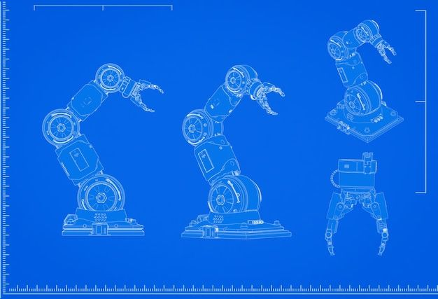Throughout the assembly process, it's important to perform thorough testing and calibration of the robot arm to ensure that it is working correctly and that all of the components are properly aligned and configured. This can include testing the movement of the arm, the functionality of the sensors and actuators, and the performance of the control software.

The assembly of a robotic arm manipulator is a complex process that requires a deep understanding of mechanical, electrical, and software engineering principles. The mechanical assembly stage involves assembling the various mechanical components of the robot arm, such as the joints, links, and end effector. The electrical installation stage involves installing the various electrical components of the robot arm, such as the sensors, actuators, and control system. The software integration stage involves integrating the control software and programming software into the robot arm.

1.6 Mechanical Assembly Using Robotic Arms

Robotic arms are increasingly being used in the field of mechanical assembly for their accuracy, speed, and repeatability. Mechanical assembly refers to the process of putting together different components to form a finished product. The use of robotic arms in mechanical assembly offers many advantages over manual assembly, including increased production rates, reduced production costs, and improved product quality. In this article, we will provide a step-by-step guide to the process of mechanical assembly using robotic arms.

Step 1: Define the Assembly Process The first step in any mechanical assembly process is to define the process itself. This involves determining the components that will be assembled, the order in which they will be assembled, and the tools and equipment that will be used. The assembly process should be designed with the capabilities of the robotic arm in mind to ensure that it can perform the required tasks.

Step 2: Design the Assembly Line Once the assembly process has been defined, the next step is to design the assembly line. This involves determining the physical layout of the assembly line, including the location of the robotic arm and any other equipment, such as conveyors, tooling stations, and storage areas. The design of the assembly line should take into account the overall production rate, as well as the need for access and maintenance of the equipment.

Step 3: Program the Robotic Arm The next step is to program the robotic arm for the assembly process. This involves writing the code that will control the arm's movements, as well as determining the parameters for the arm's movements, such as speed and accuracy. The program should be tested on a simulation or in a laboratory setting before being deployed in a production environment to ensure that it performs as expected.

Step 4: Install and Test the Assembly Line Once the assembly line has been designed and the robotic arm has been programmed, the next step is to install and test the assembly line. This involves physically setting up the equipment, connecting all necessary electrical and pneumatic lines, and testing the robotic arm to ensure that it performs the assembly process correctly. Any issues that are encountered during this phase should be addressed before the assembly line is put into production.

Step 5: Start Production The final step is to start production. This involves training operators on the assembly line, setting up the necessary quality control processes, and monitoring the performance of the assembly line to ensure that it meets production goals.

Mechanical assembly using robotic arms offers many advantages over manual assembly, including increased production rates, reduced production costs, and improved product quality. By following the steps outlined in this article, manufacturers can ensure that their mechanical assembly process is well-designed and optimized for the use of robotic arms.

Robotic arms can also increase worker safety by reducing the need for manual labor and handling of heavy components. They can also work continuously without the need for breaks or rest, leading to higher production rates and efficiency. It is important to note that the use of robotic arms in mechanical assembly requires significant investment in equipment, programming, and training. However, the benefits in terms of increased productivity and quality often outweigh the initial costs. Moreover, regular maintenance and updates are necessary to ensure that the robotic arms continue to perform optimally and efficiently. This can include software updates, replacement of worn-out parts, and calibration of sensors. Overall, mechanical assembly using robotic arms is a highly effective and efficient way of assembling products, providing manufacturers with a competitive advantage in terms of speed, quality, and cost-effectiveness.

1.7 Electrical Setup of a Robotic Arm

Electrical setup is a crucial aspect of configuring a robotic arm. This setup involves connecting the electrical components of the arm, such as the motors, sensors, and controllers, to the power supply and to each other. In this article, we will provide a step-by-step guide to the electrical setup of a robotic arm, with a focus on key concepts and best practices.

Step 1: Determine Power Requirements The first step in electrical setup is to determine the power requirements of the robotic arm. This involves determining the voltage and current requirements of the motors, sensors, and controllers, as well as any other electrical components. The power requirements will determine the size and type of power supply that is needed for the arm.

Step 2: Install Power Supply The next step is to install the power supply. This involves connecting the power supply to the electrical components of the arm, as well as connecting it to a suitable power source. The power supply should be installed in a location that is easily accessible for maintenance and repair.

Step 3: Connect Motors and Sensors The next step is to connect the motors and sensors to the power supply and to each other. The motors should be connected to the power supply, and the sensors should be connected to the controllers. The connections should be made using appropriate cables and connectors to ensure that they are secure and reliable.

Step 4: Program Controllers The next step is to program the controllers. This involves writing the code that will control the movements of the arm and the readings from the sensors. The code should be written in a programming language that is compatible with the controllers, such as C++ or Python. The code should be tested on a simulation or in a laboratory setting before being deployed in a production environment to ensure that it performs as expected.

Step 5: Test and Calibrate Once the electrical setup is complete, the next step is to test and calibrate the arm. This involves testing the movements of the arm and the readings from the sensors to ensure that they are accurate and consistent. Any issues that are encountered during this phase should be addressed before the arm is put into production.

Example: Consider a robotic arm with six motors and four sensors. The power requirements for the motors are 24V and 4A, and the power requirements for the sensors are 5V and 0.5A. A suitable power supply for the arm would be a 24V and 10A power supply. The motors would be connected to the power supply using appropriate cables and connectors, and the sensors would be connected to the controllers using appropriate cables and connectors. The controllers would be programmed using C++, and the code would be tested on a simulation before being deployed in a production environment. The arm would then be tested and calibrated to ensure that it performs as expected.

Electrical setup is a crucial aspect of configuring a robotic arm. By following the steps outlined in this article, and focusing on key concepts and best practices, manufacturers can ensure that their robotic arm is properly configured and optimized for its intended use.

1.8 Conclusion

The design, construction and operation of a robotic arm manipulator is a multi-disciplinary field that involves the integration of mechanical, electrical and software engineering concepts. The mechanical engineering perspective focuses on the design and assembly of the mechanical components of the robot, such as the joints, links, and end-effector, which provide the structural support and movement capabilities to the robot. The electrical engineering perspective focuses on the installation and integration of the electrical components, such as sensors and actuators, which enable the robot to perceive and interact with its environment. The software engineering perspective focuses on the design and implementation of the control software and programming software, which enable the robot to process sensor data, execute tasks and make decisions. Additionally, Artificial Intelligence techniques such as machine learning, computer vision, and deep learning can be used to improve the robot's ability to recognize objects, plan and execute tasks, and adapt to new situations. The assembly process involves the integration of all these disciplines and requires careful consideration of the design and implementation of each component, as well as thorough testing and calibration to ensure correct operation.

2.1 "Selecting the Right Robotic Arm Manipulator: Understanding the Different Types and Their Applications"

Robotic arm manipulators are highly versatile machines that can be used for a wide range of tasks and applications. However, it's important to choose the right type of robotic arm manipulator for the specific task or application at hand. In this article, we will explore the different types of arm robots available and their specific characteristics and capabilities.

* One of the most common types of arm robot is the articulated arm. This type of robot is composed of a series of joints that allow the arm to move in multiple directions, providing a high degree of flexibility and precision. Articulated arm robots are commonly used in industrial manufacturing and assembly, as well as in research and development. They are also used in robotic welding, painting, and other industrial applications. Articulated arm robots are typically composed of three to seven joints.
* Another type of arm robot is the six-axis robot. This type of robot is composed of six joints that allow the arm to move in multiple directions, providing a high degree of flexibility and precision. Six-axis robots are commonly used in industrial manufacturing and assembly, as well as in research and development. They are also used in robotic welding, painting, and other industrial applications.
* A collaborative robot, also known as a cobot, is a type of robot that is designed to work alongside humans in a shared workspace. These robots are equipped with safety features such as force sensing and stopping mechanisms to ensure the safety of the human operators. Collaborative robots are commonly used in manufacturing and assembly, as well as in research and development. They are also used in tasks such as machine tending, packaging, and material handling.
* SCARA (Selective Compliance Assembly Robot Arm) robots are also commonly used in industrial manufacturing and assembly. These robots are characterized by their two parallel rotary joints that provide a high degree of precision and speed. SCARA robots are typically used for tasks such as assembly, material handling, and packaging.
* Cartesian robots are also known as gantry robots and have three linear joints that move in a Cartesian coordinate system. These robots are commonly used in manufacturing and assembly, as well as for material handling and packaging. They are also used for tasks such as machine tending and pick-and-place.
* Cylindrical robots are characterized by their cylindrical shape and are commonly used in manufacturing and assembly, as well as for material handling and packaging. They are also used for tasks such as machine tending and pick-and-place.
* Spherical/Polar robots have three rotary joints that are positioned in a spherical coordinate system. These robots are commonly used in manufacturing and assembly, as well as for material handling and packaging. They are also used for tasks such as machine tending and pick-and-place.
* Parallel/Delta robots are characterized by their parallel kinematics, and are commonly used in manufacturing and assembly, as well as for material handling and packaging. They are also used for tasks such as machine tending and pick-and-place.
* Anthropomorphic robots have a human-like shape and are commonly used in manufacturing and assembly, as well as for material handling and packaging.

The selection of the appropriate arm robot depends on the specific task or application for which it will be used. Different types of arm robots include articulated, six-axis, collaborative, SCARA, Cartesian, cylindrical, spherical/polar, parallel/delta, and anthropomorphic robots, each with its own unique characteristics and capabilities. It's important to carefully evaluate the specific requirements of the task or application and choose the most appropriate arm robot to meet those requirements.

3.1 "Machine Learning and Arm Robots: Enhancing Performance and Capabilities"

The integration of machine learning techniques into arm robots has the potential to significantly enhance their performance and capabilities. Machine learning, a subset of Artificial Intelligence, is a method of teaching computers to learn from data, without being explicitly programmed. By incorporating machine learning algorithms into arm robots, they can learn to perform tasks more efficiently and accurately, adapt to new situations, and even make decisions on their own.

* One application of machine learning in arm robots is in the field of object recognition. By training a machine learning model with a large dataset of images, an arm robot can learn to recognize objects and make decisions on how to interact with them. This can be applied in tasks such as grasping and sorting objects, where the robot needs to identify and pick up specific items.
* Another application of machine learning in arm robots is in the field of motion planning. By training a machine learning model with data on the robot's kinematics and dynamics, an arm robot can learn to plan and execute movements more efficiently and safely. This can be applied in tasks such as assembly and welding, where the robot needs to move in specific ways to perform the task correctly.

In addition to these applications, machine learning can also be used to improve the control of arm robots. By using techniques such as reinforcement learning, an arm robot can learn to make decisions and control its movements based on feedback from its sensors.

To further enhance the capabilities of arm robots, it is important to consider the integration of multiple machine learning techniques. For example, combining object recognition with motion planning can enable the robot to identify and pick up specific objects, and then move them to a specific location.

Moreover, the development of more advanced machine learning algorithms such as deep learning, can also help to improve the performance of arm robots. Deep learning algorithms are based on neural networks, which are capable of handling large and complex datasets, and can be used to improve the robot's ability to recognize objects, plan and execute tasks, and adapt to new situations.

The integration of machine learning techniques into arm robots has the potential to significantly enhance their performance and capabilities. In addition to the applications and techniques mentioned earlier, machine learning can also be used to improve the control of arm robots through techniques such as inverse kinematics and impedance control. Inverse kinematics is a technique used to determine the joint angles of a robotic arm in order to reach a specific end-effector position. Impedance control is a technique used to control the interaction forces between the robot and its environment. By incorporating machine learning algorithms, arm robots can learn to perform these control techniques more effectively and efficiently.

One specific example of how machine learning can be used to improve the performance of arm robots is through the use of deep neural networks (DNNs) for object recognition. DNNs are a type of machine learning model that are particularly well-suited for image and object recognition tasks. By training a DNN with a large dataset of images, an arm robot can learn to recognize objects and make decisions on how to interact with them.

Here's an example of using a DNN for object recognition using the TensorFlow library in Python:

# Importing necessary libraries

import tensorflow as tf

from tensorflow import keras

# Loading the dataset

(x_train, y_train), (x_test, y_test) = keras.datasets.cifar10.load_data()

# Creating the model

model = keras.Sequential([

    keras.layers.Conv2D(32, (3, 3), activation='relu', input_shape=(32, 32, 3)),

    keras.layers.MaxPooling2D((2, 2)),

    keras.layers.Conv2D(64, (3, 3), activation='relu'),

    keras.layers.MaxPooling2D((2, 2)),

    keras.layers.Flatten(),

    keras.layers.Dense(64, activation='relu'),

    keras.layers.Dense(10, activation='softmax')

])

# Compiling the model

model.compile(optimizer='adam',

              loss='sparse_categorical_crossentropy',

              metrics=['accuracy'])

# Training the model

model.fit(x_train, y_train, epochs=10)

# Testing the model

test_loss

In summary, the integration of machine learning techniques into arm robots can significantly enhance their performance and capabilities. One specific example is using deep neural networks (DNNs) for object recognition. DNNs are a type of machine learning model that are particularly well-suited for image and object recognition tasks. By training a DNN with a large dataset of images, an arm robot can learn to recognize objects and make decisions on how to interact with them. An example of implementing this is using the TensorFlow library in Python to create, compile and train the DNN model and then using it to classify objects. Additionally, machine learning can also be used to improve the control of arm robots through techniques such as inverse kinematics and impedance control.

Machine learning techniques have the potential to significantly enhance the performance and capabilities of arm robots. One of the main advantages of using machine learning in arm robots is the ability to adapt to new situations and environments. For example, if an arm robot is trained with a dataset of images of objects, it can then recognize and interact with them in the real-world environment. This ability to adapt to new situations is particularly useful in industrial settings where the robot may encounter different products and materials.

Another advantage of using machine learning in arm robots is the ability to perform tasks more efficiently and accurately. By training the robot with a dataset of sensor data, it can learn to plan and execute movements more efficiently and safely. This can be particularly useful in tasks such as welding, painting, and assembly where precision and accuracy are critical.

Furthermore, machine learning can also be used to improve the control of arm robots. By using techniques such as reinforcement learning, an arm robot can learn to make decisions and control its movements based on feedback from its sensors. This can be particularly useful in tasks such as grasping and sorting objects, where the robot needs to adjust its movements based on the properties of the object.

Additionally, using advanced machine learning algorithms such as deep learning can also help to improve the performance of arm robots. Deep learning algorithms are based on neural networks, which are capable of handling large and complex datasets, and can be used to improve the robot's ability to recognize objects, plan and execute tasks, and adapt to new situations.

To further enhance the capabilities of arm robots, it is important to consider the integration of multiple machine learning techniques. For example, combining object recognition with motion planning can enable the robot to identify and pick up specific objects, and then move them to a specific location.

In conclusion, the integration of machine learning techniques into arm robots has the potential to significantly enhance their performance and capabilities. By incorporating machine learning algorithms, arm robots can learn to adapt to new situations, perform tasks more efficiently and accurately, and improve their control. It's important to carefully evaluate the specific requirements of the task or application and choose the most appropriate machine learning techniques to meet those.

3.2 Reinforcement learning

Reinforcement learning (RL) is a type of machine learning that focuses on training agents to make decisions in an environment by maximizing a reward signal. The agent receives feedback in the form of rewards or penalties for its actions, and uses this feedback to improve its decision-making over time.

In RL, the agent interacts with an environment, where it selects actions to perform based on its current state. The environment then transitions to a new state and the agent receives a reward or penalty for its action. The agent's goal is to learn a policy, which is a mapping from states to actions, that maximizes the expected cumulative reward over time.

One of the key components of RL is the use of a value function, which estimates the expected cumulative reward for a given state or state-action pair. The agent can use this value function to guide its decision-making, by selecting actions that lead to states with high estimated values.

A popular algorithm for RL is Q-learning, which is a type of model-free, off-policy RL algorithm. Q-learning uses a Q-table to store the estimated values for all state-action pairs. At each time step, the agent selects the action that maximizes the Q-value for its current state. The Q-values are then updated using the Bellman equation, which expresses the Q-value for a state-action pair in terms of the Q-values for the next state.

Here's an example of Q-learning implemented in Python:

import gym

import numpy as np

# Define the Q-table and the learning parameters

q_table = np.zeros((num_states, num_actions))

alpha = 0.1

gamma = 0.9

# Define the environment

env = gym.make("FrozenLake-v0")

# Define the training loop

for episode in range(num_episodes):

    # Reset the environment and get the initial state

    state = env.reset()

    done = False

    while not done:

        # Select an action based on the current state

        action = np.argmax(q_table[state,:] + np.random.randn(1,num_actions)*(1./(episode+1)))

        # Perform the action and observe the next state and reward

        next_state, reward, done, info = env.step(action)

        # Update the Q-value for the current state-action pair

        q_table[state, action] = q_table[state, action] + alpha*(reward + gamma*np.max(q_table[next_state,:]) - q_table[state, action])

        # Update the current state

        state = next_state

In this example, we are using the FrozenLake-v0 environment from the OpenAI Gym library, which is a simple grid-based game where the agent must navigate to a goal while avoiding holes. The Q-table is initialized with all zeros, and the learning parameters are set to alpha = 0.1 and gamma = 0.9. The agent uses an epsilon-greedy strategy to select actions, where it selects the action with the highest Q-value with probability (1-epsilon) and a random action with probability epsilon. The Q-values are updated using the Bellman equation at each time step.

3.3 "Training an Arm Robot for Object Recognition: Techniques and Applications"

Robotic arm manipulators are widely used in various industries for tasks such as grasping, sorting, and transporting objects. One of the key challenges in these applications is to enable the robot to accurately recognize and interact with the objects in its environment. In this article, we will discuss some of the techniques and methods used to train arm robots for object recognition, and we will provide an example of code for grasping and sorting objects using a robotic arm.

One of the most popular techniques for training arm robots for object recognition is deep learning. Deep learning is a type of machine learning that uses neural networks to learn from data. Convolutional Neural Networks (CNNs) are a type of deep learning model that have been shown to be effective in object recognition tasks. CNNs can be trained to recognize objects in images or videos by learning the features of the objects from a large dataset of labeled images.

Another technique used to train arm robots for object recognition is computer vision. Computer vision is a field of study that deals with how computers can be made to interpret and understand images and videos. In the context of arm robots, computer vision algorithms can be used to detect and track objects in the robot's environment, and to extract features from the images that can be used for object recognition.

In terms of grasping and sorting objects, one way to accomplish this is by using a robotic arm equipped with a gripper. The gripper is a device that allows the robot to pick up and hold objects. A common way to control the gripper is by using a force/torque sensor, which measures the force applied by the gripper on the object. This allows the robot to adjust the grip strength to ensure that it holds the object securely without damaging it.

Here's an example of Python code for grasping and sorting objects using a robotic arm with a gripper:

import numpy as np

import cv2

# Load the object recognition model

model = cv2.dnn.readNetFromTensorflow('model.pb', 'model.pbtxt')

# Initialize the gripper

gripper = Gripper()

while True:

    # Capture image from camera

    image = cv2.imread('image.jpg')

    # Run the object recognition model on the image

    blob = cv2.dnn.blobFromImage(image, size=(300, 300), swapRB=True, crop=False)

    model.setInput(blob)

    output = model.forward()

    # Find the object with the highest confidence score

    class_id = np.argmax(output[0])

    confidence = output[0][class_id]

    # If the confidence score is above a threshold, grasp the object

    if confidence > 0.5:

        # Move the robot arm to the object's location

        move_arm_to_object(object_location)

        # Close the gripper

        gripper.close()

        # Move the robot arm to the sorting location

        move_arm_to_sorting_location()

        # Open the gripper

        gripper.open()

The above code is an example of how to use a pre-trained object recognition model in order to detect and classify objects in the robot's environment. The code also demonstrates how to control a gripper to pick up and sort objects based on the object's classification.

3.4 Motion Planning

Motion planning is a critical aspect of robotic arm manipulation, as it involves determining the optimal path for the robot to take in order to successfully complete a given task. One key element of motion planning is training a machine learning model with data of the robot's kinematics and dynamics. This allows the arm robot to learn and understand the relationships between its various components and how they interact, allowing it to plan and execute movements with greater efficiency and accuracy.

There are various techniques that can be used to train a machine learning model for motion planning on arm robots. One popular approach is to use supervised learning, where the model is trained on a set of labeled data that represents the robot's kinematics and dynamics. This data can be collected through real-world observations of the robot or through simulations of its movements.

Another approach is to use reinforcement learning, where the robot is trained through trial and error. In this method, the robot is given a task to perform and is rewarded for completing it successfully. Over time, the robot learns to optimize its movements in order to achieve the desired outcome.

In order to train a machine learning model for motion planning, it is important to have a good understanding of the robot's kinematics and dynamics. This includes knowledge of the robot's joints, links, and sensors, as well as how they interact with one another. Additionally, it is important to have a good understanding of the robot's control system, as this will have a significant impact on the robot's ability to plan and execute movements.

Once the model is trained, it can be integrated into the robot's control system, allowing it to perform tasks such as grasping and sorting objects. For example, the robot can be programmed to identify and pick up specific items using image recognition techniques, and then use its trained motion planning abilities to sort them into designated areas.

Training a machine learning model for motion planning on arm robots is a crucial step in enhancing their performance and capabilities. By understanding the robot's kinematics and dynamics and using techniques such as supervised and reinforcement learning, it is possible to train the robot to plan and execute movements more efficiently and accurately. The implementation of motion planning model can be done with any general purpose programing languages like Python, C++.